Retrieval questions
Work out without a calculator:  $$4\frac{1}{3}+2\frac{3}{4}$$ | The Jones family use ¾ of a carton of milk every day.  What is the minimum number of cartons needed so that the family have enough milk for 7 days? You must show your workings.
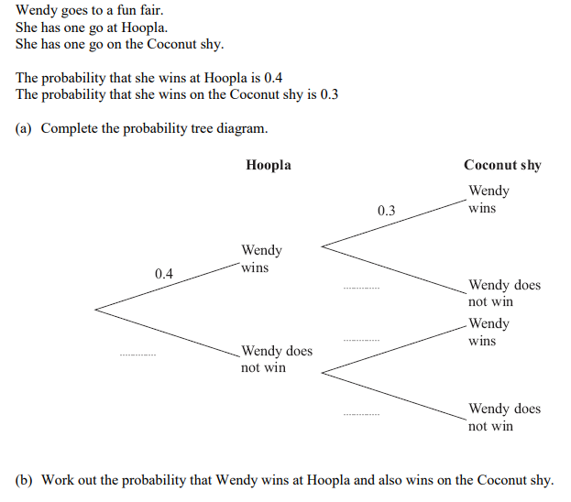 | Solve:  4 (x - 5) = 7x + 2

