Retrieval questions
Spinner A has the numbers 1, 3, 6 and 7. Spinner B has the numbers 2, 4 and 9. The results of each spinner are multiplied together.  - Draw this in a sample space.  - Find the probability of getting an odd number, express your answer as a fraction. | 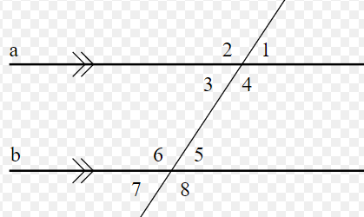  Lines a and b are parallel.  Write down two angles which are corresponding
Below is a list of numbers:  21, 23, 25, 27, 29  Write down all numbers from the list which are:  - Prime numbers  - Square numbers  - Cube numbers | Express 90 as a product of prime factors.

