Retrieval questions
In January a company sold 300 cars. In February they sold 20% less cars than in January. In March they sold 40% more cars than they sold in February. Find the percentage change between January and March. | Find the values of x and y:  97⁰  83⁰  5x+2y  4x+5y
Name each part of the circles  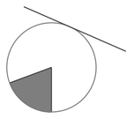 | Factorise and solve:  $x^{2}-12x+32=0$

