OCR Grade Boundaries 9-1
2017-2019

Foundation:
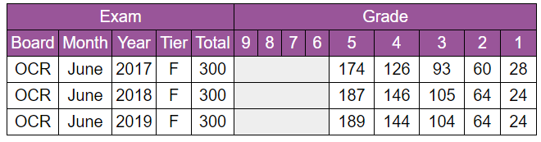

Higher:
