Further Maths GCSE
Factor Theorem Questions
1 | 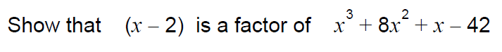
2
3 | 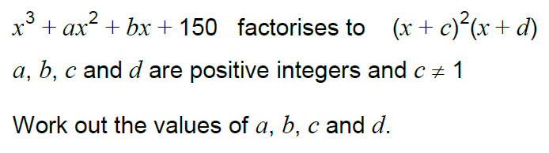
4 | 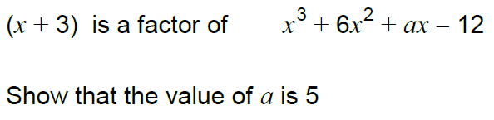
5 | 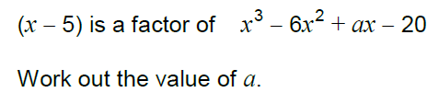
6 | 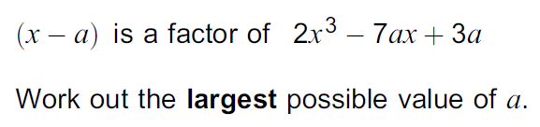
7 | 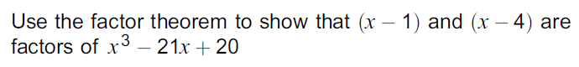
8 | 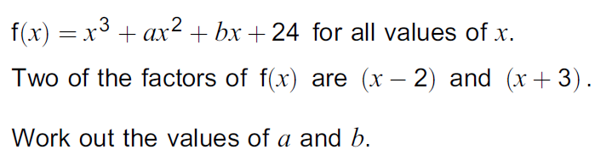
9

